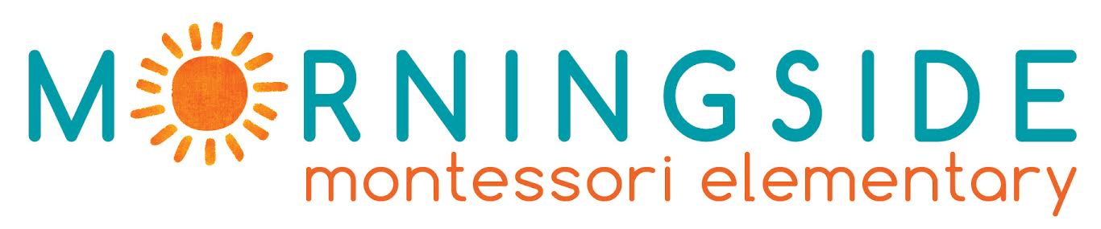

ERASMUS PLACEMENT OFFER

EMPLOYER INFORMATION
Name of the Organization | Morningside Montessori Elementary Private School
Address | Dorieon 20, Ayios Andreas
Postal Code | 1101
City | Nicosia , Cyprus
Telephone | +35799319536
Facebook page | https://www.facebook.com/MorningsideCyprus/
Morningside at a Glance | Morningside Montessori is the first elementary in Cyprus to follow the Montessori Method, as well as the first trilingual (English, Greek and Turkish) school on the island, that started operation in September 2017.  Morningside Montessori Elementary is a non-profit company with founding members from the fields of Montessori education, developmental psychology, psychoanalysis, sociology, anthropology, peace education, architecture, and business administration and accounting.  Our learning environment, which is not bound within the classroom, is hands-on and child-directed. We aim to educate the whole child through a comprehensive Montessori education that cultivates outdoor learning, self-directed action, flexible thinking, creativity, and non-standardized models of problem-solving.  We believe that we must embrace each other with empathy, in order to promote a culture of peace and understanding. It is for this reason that it is imperative to learn and understand each other’s language. In order to bring the two larger communities of the island of Cyprus together, both Greek and Turkish are taught to students. The main language of instruction is English.

CONTACT DETAILS
Contact Person (s) | Evi Eftychiou / Angeliki Yiassemides
Title | Directors
Direct Telephone Number | +35799319536 / +35799972237
Direct Email Address | evi@morningsidecyprus.com  angeliki@morningsidecyprus.com

PLACEMENT INFORMATION
Description of Activities | The educational and administrative assistantship includes the following responsibilities:  - Organize, coordinate and participate in the educational activities (indoors and outdoors)  - Assist in the preparation of educational material  - Assist in tasks related with the daily operation of the school (i.e. supervise children during work cycle, invigilation during break time printing and laminating, Montessori educational material, etc)  - Assist in setting up and maintaining the Montessori school environment  - Assistance in daily administrative tasks at the school  - Maintain and update school archives  - Assist in fundraising activities, festivals and events to be organized by the school
Skills and Personal Qualities | -creative flair  - strong organizational skills  -originality  -strong computer skills  -confidence, to present and explain ideas  -the ability to balance work on several projects at a time  -flexibility
Duration | Minimum 3 months – max 12 months
Working Hours | Approximately 30-40 Hours per week
Help with finding Accommodation | YES (we can provide a list with possible flats or rooms for rent)

REQIUREMENTS
Excellent English language skills | Candidates must be fluent in English.  Knowledge of Greek or Turkish will be considered an asset.
Eligible to apply | Graduates OR Students with Bachelor degree in:  - Education  - English Language and Literature
Required Documents | -CV  -Motivational Letter /email | - Proof of your English Language knowledge  -Copy of your Bachelor (if any) or any other Diploma
Please send your application at: evi@morningsidecyprus.com
Deadline: 15th of January 2022

